Homework 1 Report
Lucas Nguyen nguye800@purdue.edu
0034489397
Signal Processor Code 2.1
Explanation
Parent class implementation correctly assigns input parameter data from which future child classes can inherit common characteristics (self.data)
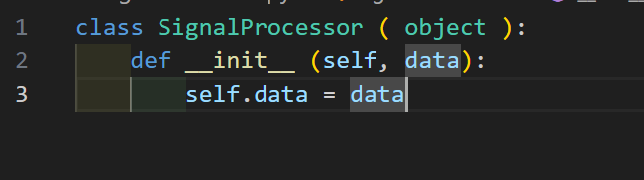

Sine Wave Code 2.2, 2.3, 2.4, 2.6
Explanation
__init__ method correctly calls parent class constructor and stores the 2 new parameters amplitude and frequency as variables.
__call__ method generates a sine wave from time steps 0 to duration-1 using the given formula for a sine wave y[n] = amplitude × sin(2π × frequency × n) and saves the values in self.data. Afterwards it prints the full wave values for all time steps as specified by instructions.
__iter__/__next__ work together to initialize an internal index used to navigate through self.data and enables iteration over signal values
__eq__ first checks if wave for comparison has an attribute data to compare against and additionally checks for equal length and will raise a ValueError with the appropriate message if different sizes as specified by instructions. Lastly, it will compare values of the wave per time step and count them as the same within a tolerance of 0.01
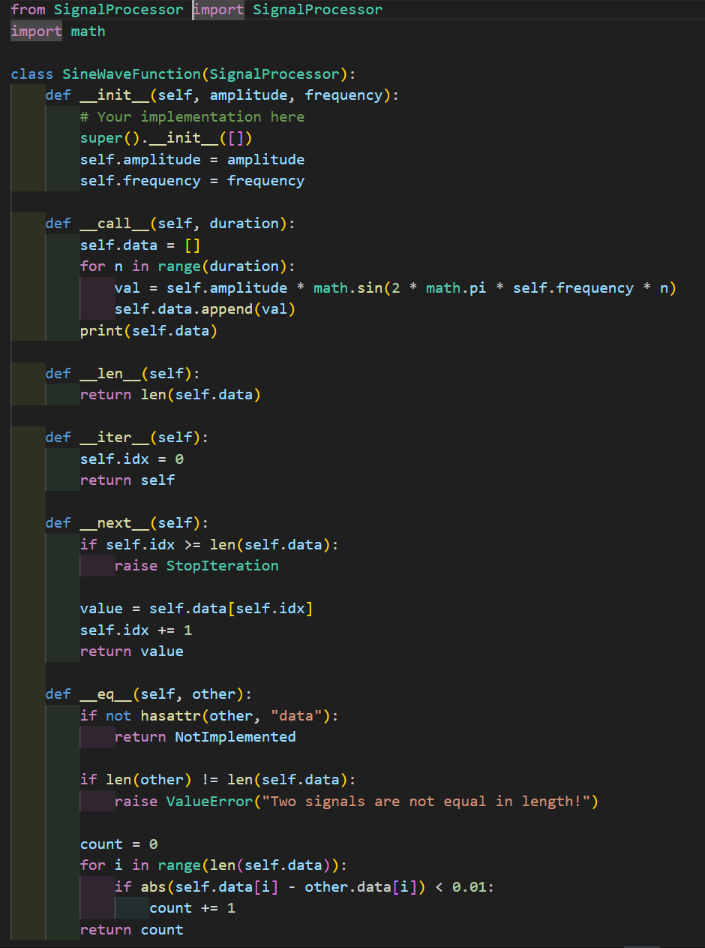

Square Wave Code 2.5, 2.6
Explanation
Square wave implements all magic methods specified for the sine wave. The only difference between the classes is that __call__ generates a square wave where the values of the wave can only be amplitude and -amplitude.
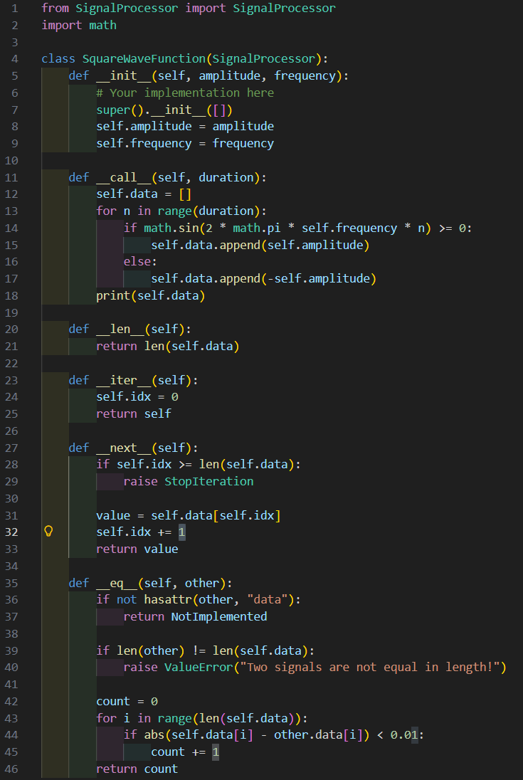
Testing Implementation Code 2.7
Explanation
Two durations were chosen for using in __call__ methods for waves in order to test different sizes of waves and verify functionality of __eq__ later in testing.
Multiple sine and square waves were created with different amplitudes and frequencies to show how parameter choices will affect wave values for both classes.
Tests were conducted by printing the name of the test which tested specific functionality of magic methods for both classes and were designed to verify correctness of edge cases in the class functionality.
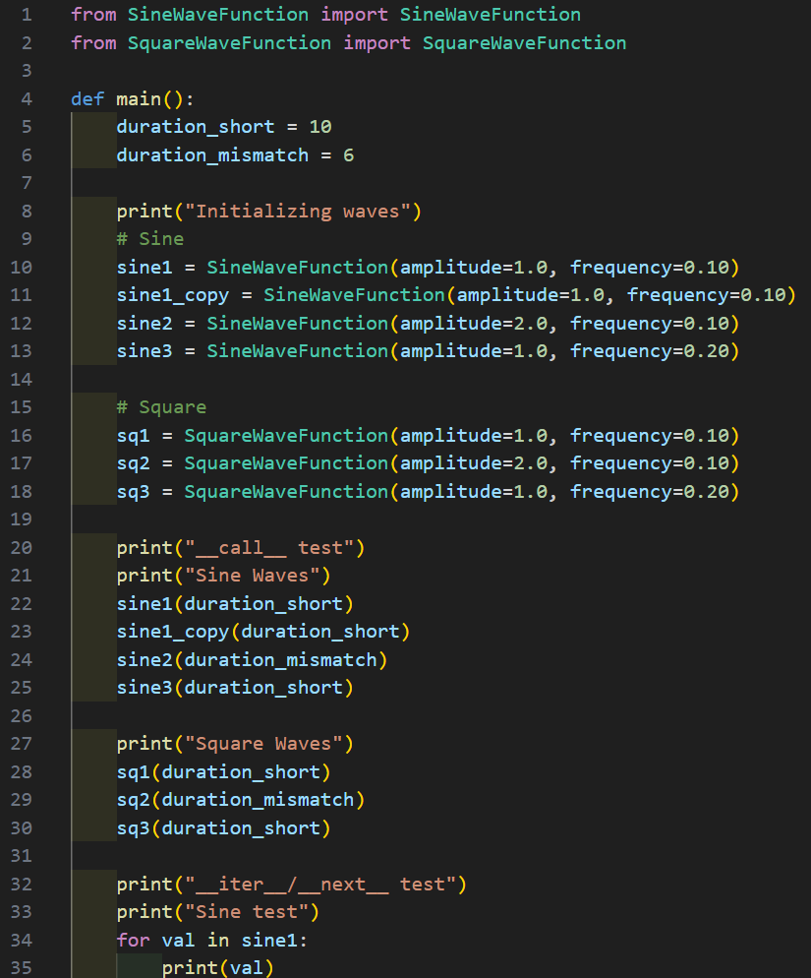
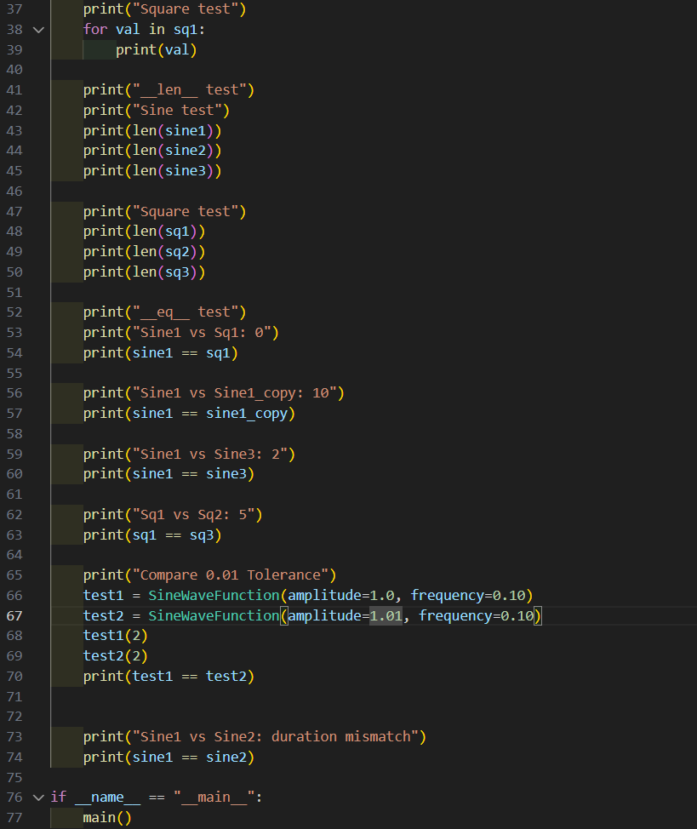

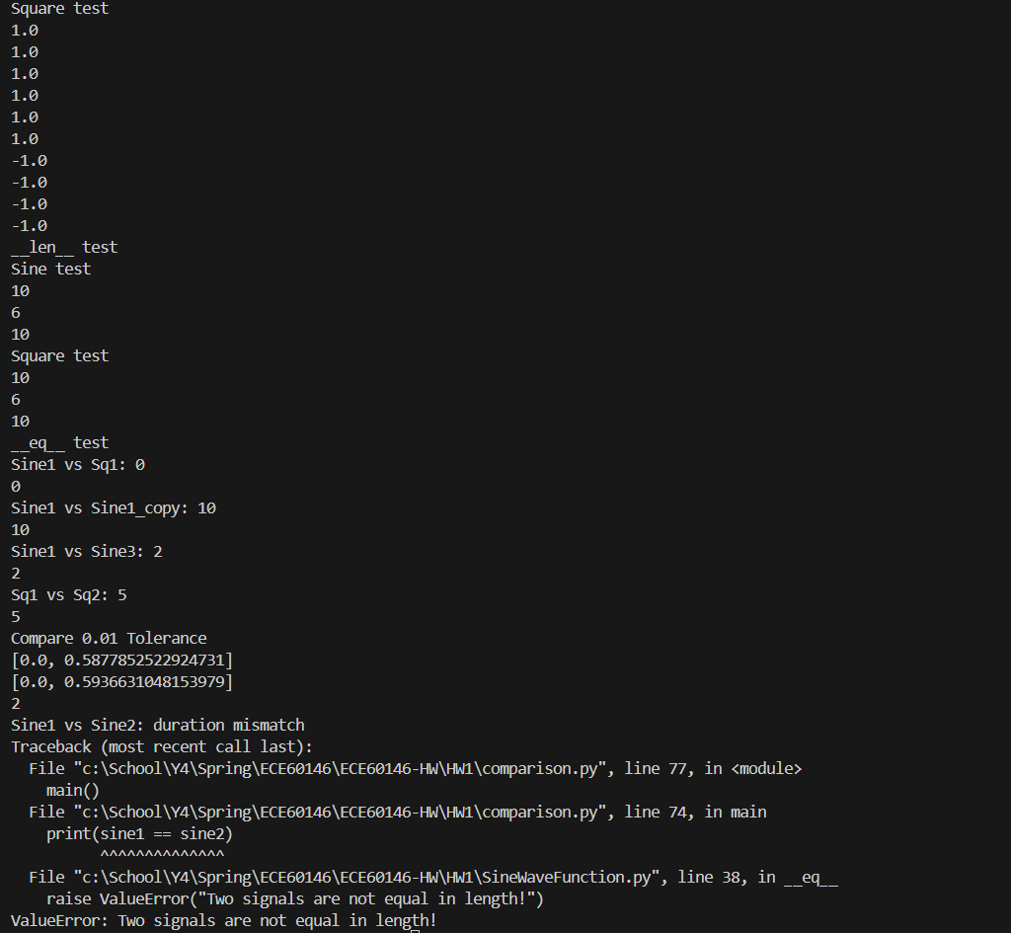
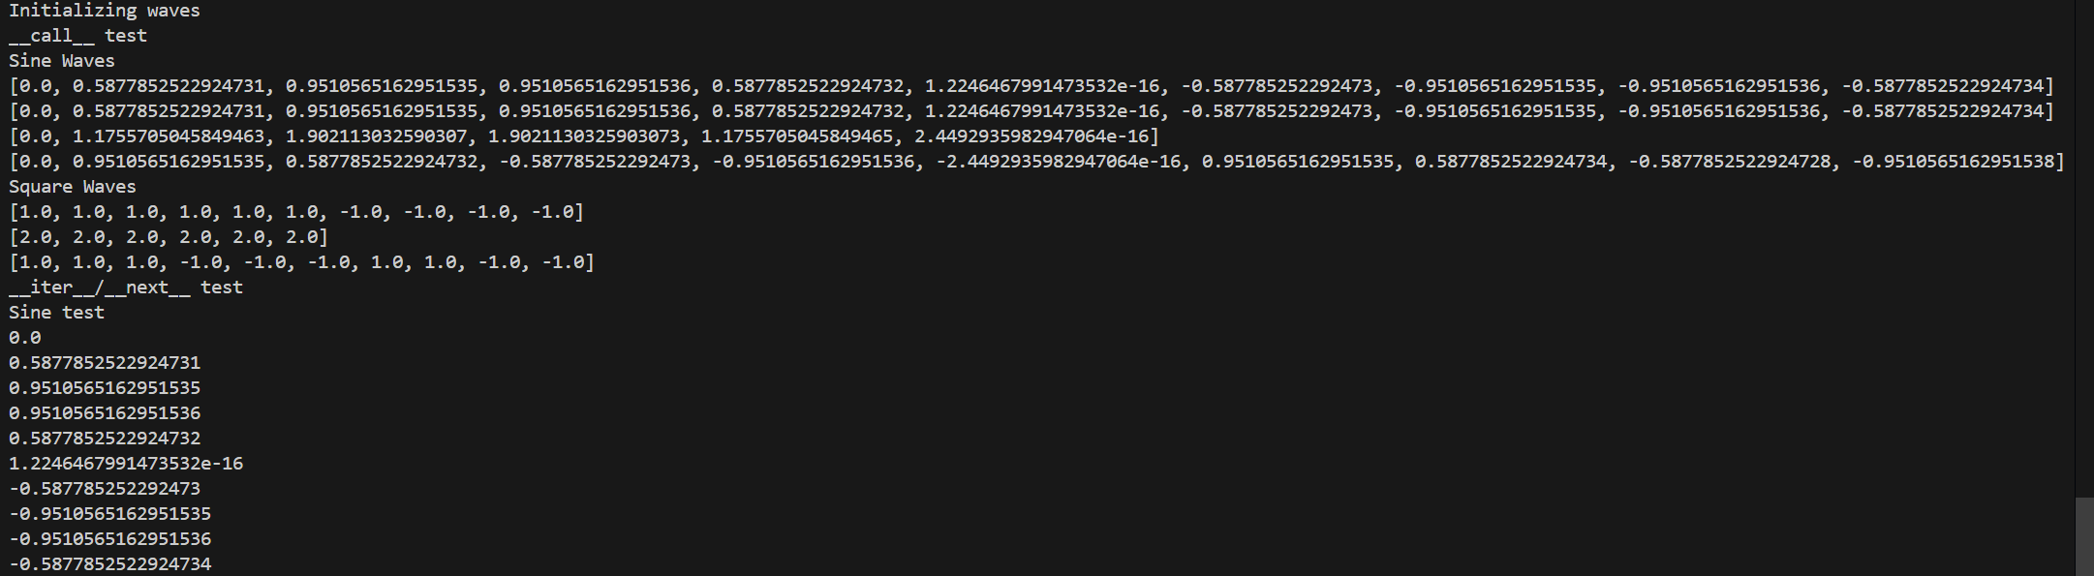
Testing Implementation Code Output 2.7

Analysis of Implementation 2.7:
Parameter Choices
Amplitudes of 1.0 and 2.0 were chosen to show vertical scaling of the wave and can be seen by comparing sine1 vs sine2 and sq1 vs sq2. Frequencies of 0.1 and 0.2 were chosen to show differences in oscillation speed and can be seen as faster sign/value changes for example sine3 achieves the same values of sine1 but temporally earlier. Amplitude of 1 and 1.01 at the bottom of the code were chosen to prove the 0.01 tolerance in the __eq__ magic method.
Observed Behavior
Sine1 produced peaks of roughly 0.95 due to the whole number time steps. Sine2 produced peaks exactly twice as large due to the amplitude changes for example 0.95->1.9. This matches the formula for the sine wave and proves that amplitude increases vertical height of the wave. For square waves they could only take two values (amplitude/-amplitude). Because of this, sq1 only outputs 1 and -1 and sine2 outputs 2 and -2. Having a lower frequency means that the wave doesn’t oscillate as quickly, because of this effect we can see that sq1 stays positive/negative for longer before changing signs whereas sq3 switches signs quicker due to having double the frequency speed.
Magic Method Demonstrations
__init__: Correctly assigns amplitude and frequency arguments of values of the class and uses super class initialization for SignalProcessor with an empty array as data.
__call__: Generates a waveform for duration n amount of time and stores it in self.data and prints the resulting wave in a single line.
__iter__/__next__: Work together to print individual entries in self.data and move the index within self.data to the next element each step.
__len__: returns the length of self.data (either 10 or 6 depending on duration entered)
__eq__: Correctly demonstrates comparing wave values with a tolerance of 0.01. Sine1 vs Sine1_copy showed that all values were the same, Sine1 vs Sq1 showed that no values were the same, Sine1 vs Sine2 showed an error due to difference in length, Sine1 vs Sine3 showed that different frequency waves still overlapped at 2 points in the wave, Sq1 vs Sq3 showed an overlap of 5 times in the wave even though they are different frequencies. Comparing the eq tolerance used amplitude of 1 and 1.01 to show that waves with slightly different values at t=1 (0.5877 vs 0.5936) still were considered equal to each other.

Bonus Section 3.1
Composite Signal Code
Explanation
Organization of the code was almost identical to the previous code for sine and square waves. The only difference was in firstly __init__ by ensuring that the composite wave was initialized with at least one wave so that it wouldn’t have a nonexistent wave, and secondly in __call__ by adding a secondary for loop to loop through the inputs that need to be composited into a single wave. This allowed for waves to be added together to form the new composite wave.
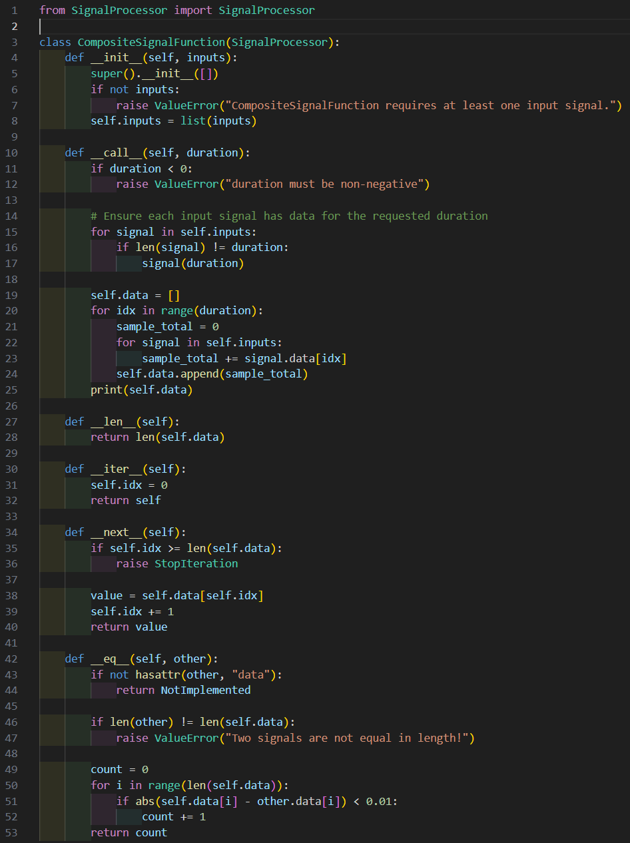

Signal Visualization 3.2
Explanation
As seen below the waves were created for a duration time of 50 as specified by instructions. The composite sign becomes larger than the sine wave when the square wave and sine wave are both the same sign validating the functionality of the composite wave code by adding together the two waves.
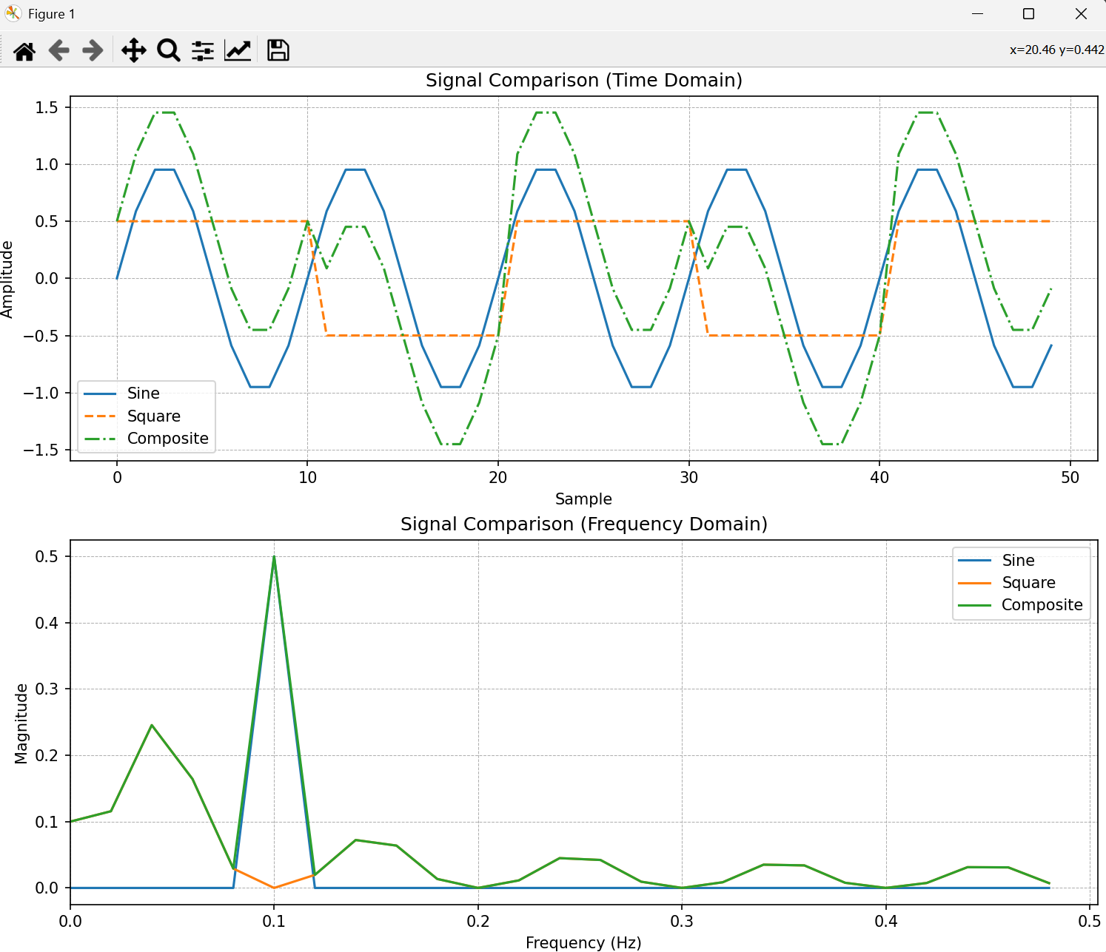
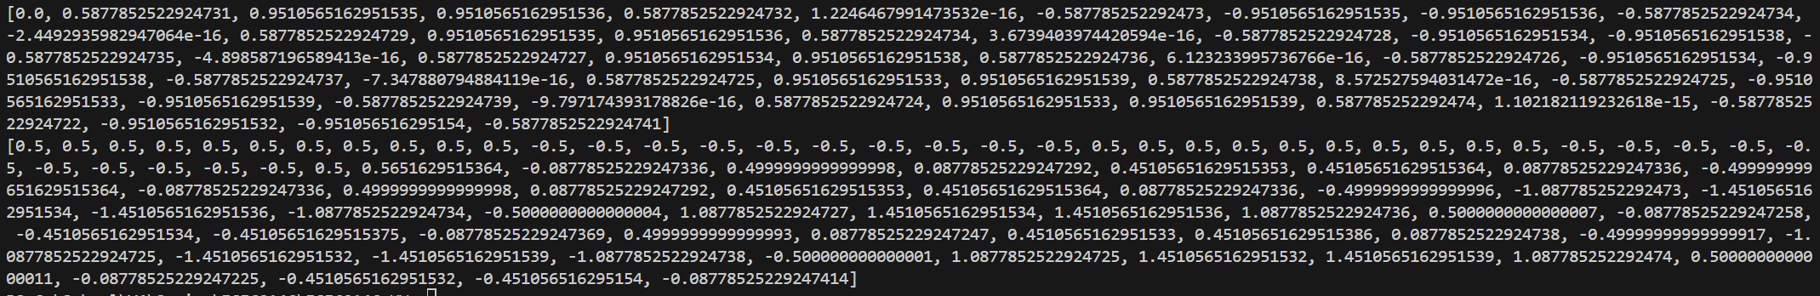

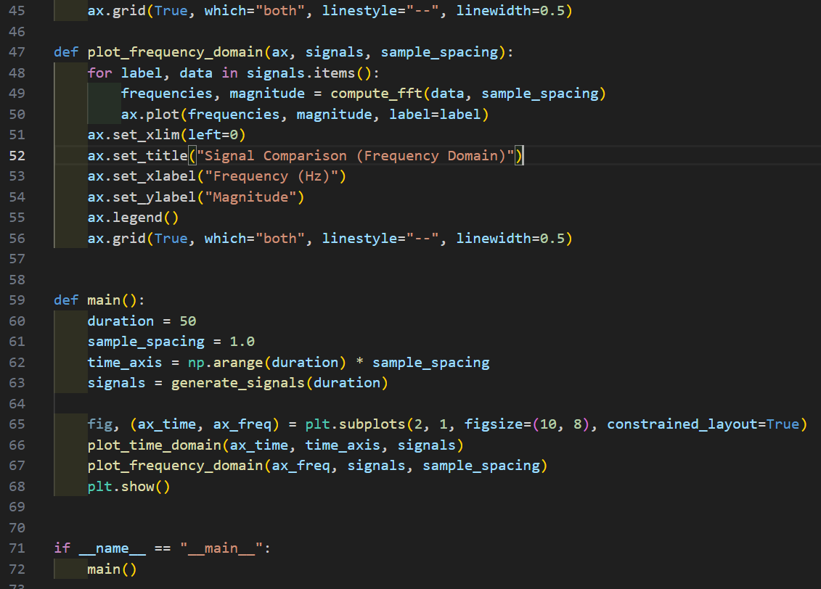
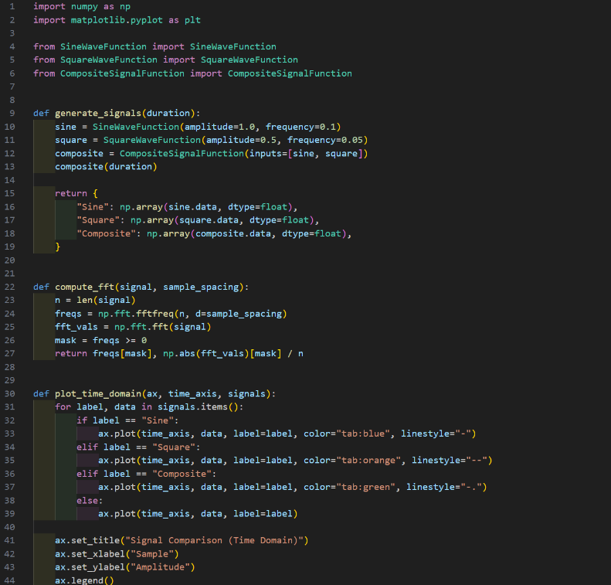
Signal Visualization Code

